MACH4METAL

metalworking machinery
Transito 21, 6909 DA Babberich, Netherlands
Tel. + 31 (0)316 – 247123
Fax. + 31 (0)316 - 247956
info@mach4metal.com
www.mach4metal.com
Bank No : 66.52.13.883
IBAN : NL33 INGB 0665 2138 83
BIC : INGBNL2A
VAT : NL 815393635B01

ZMM Turning lathe Ø 1.000 x 1.500
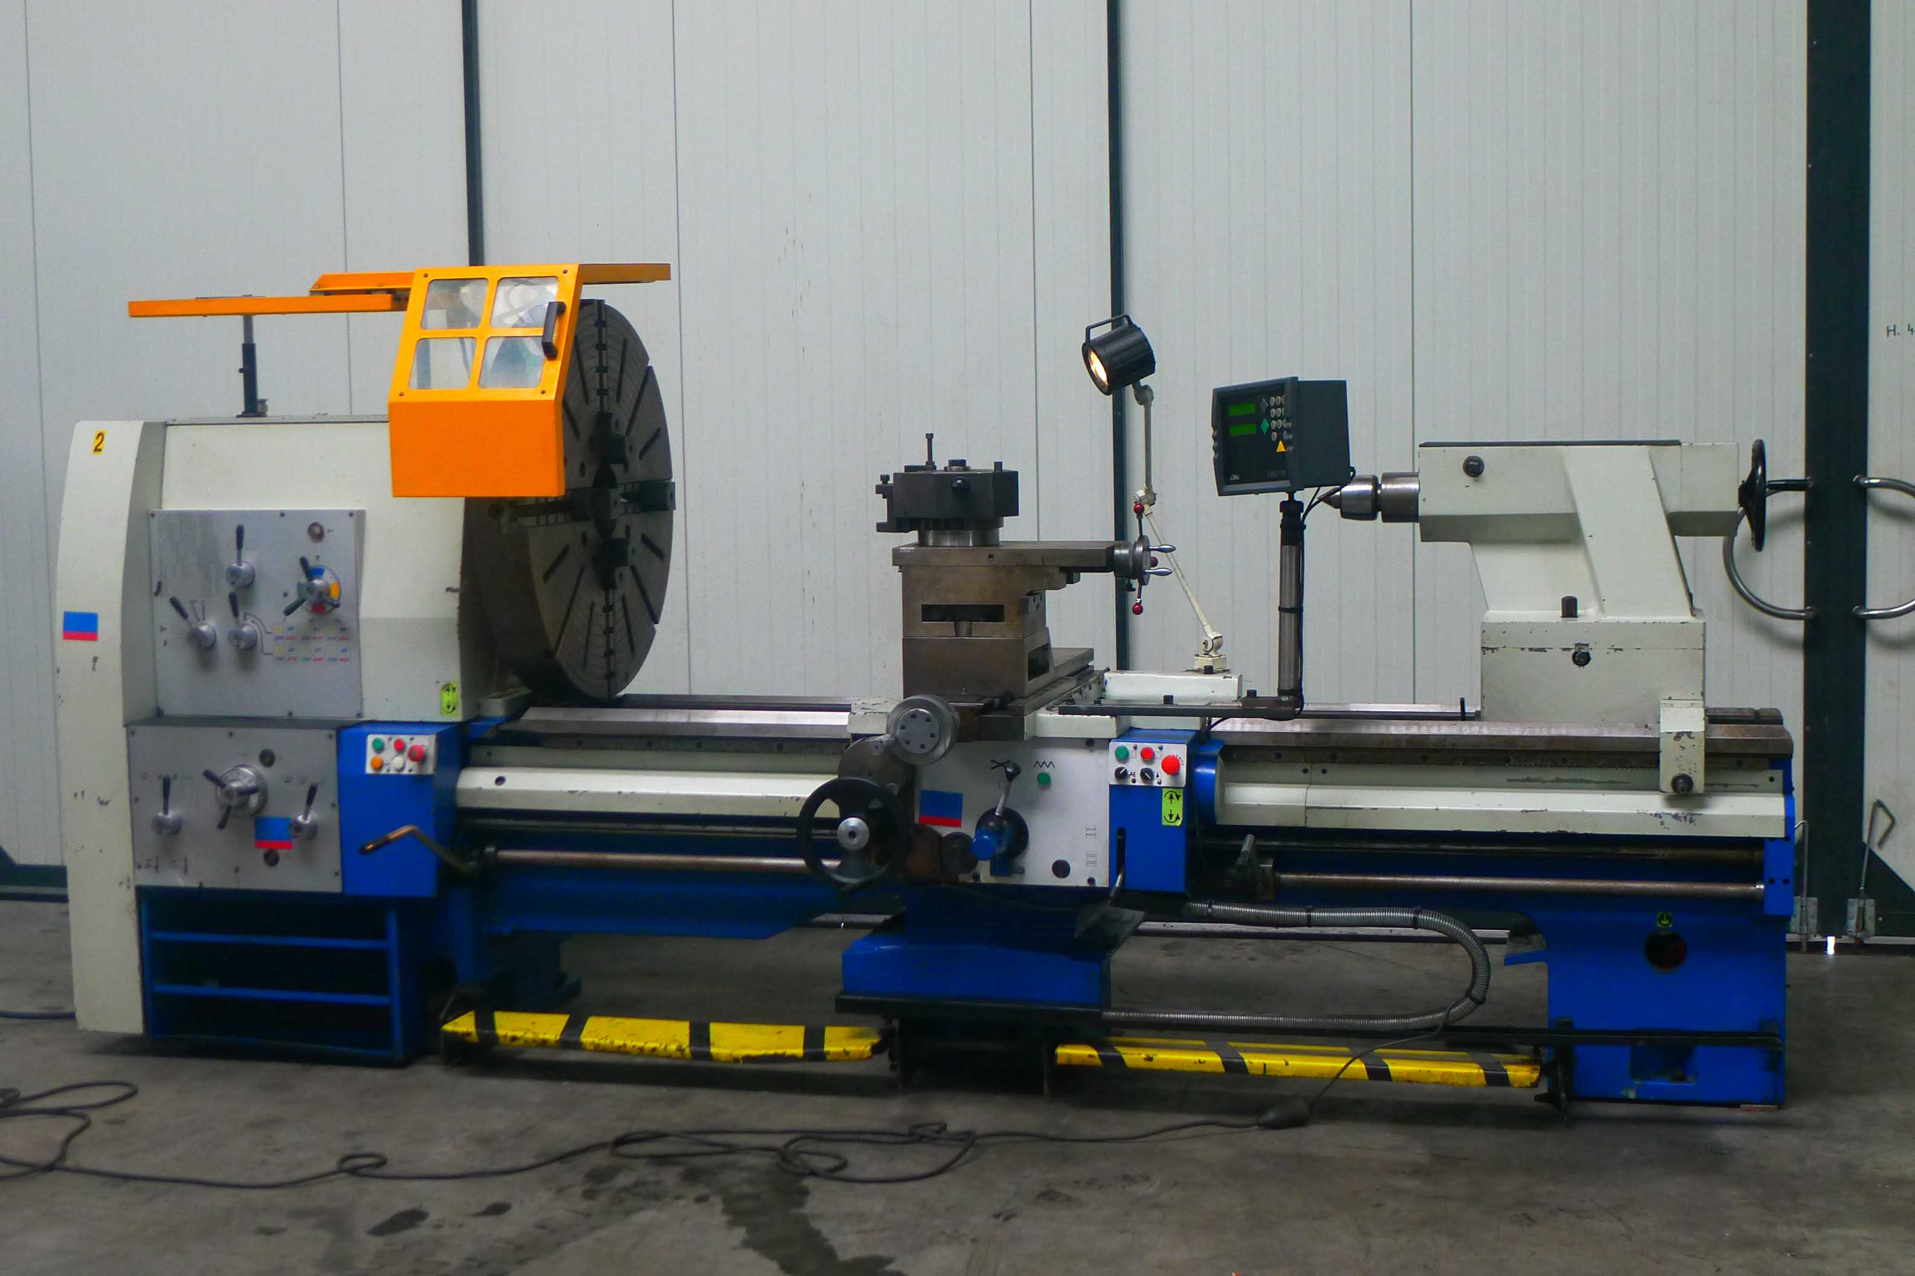
- Make : ZMM Turning lathe
- Typ : C 13 SH
- YOP : 2001
- Mach.No : 00…

- Swing over bed : 1.000
- Swing over support : 740
- Swing in the gap : 1.250
- Bed width : 540
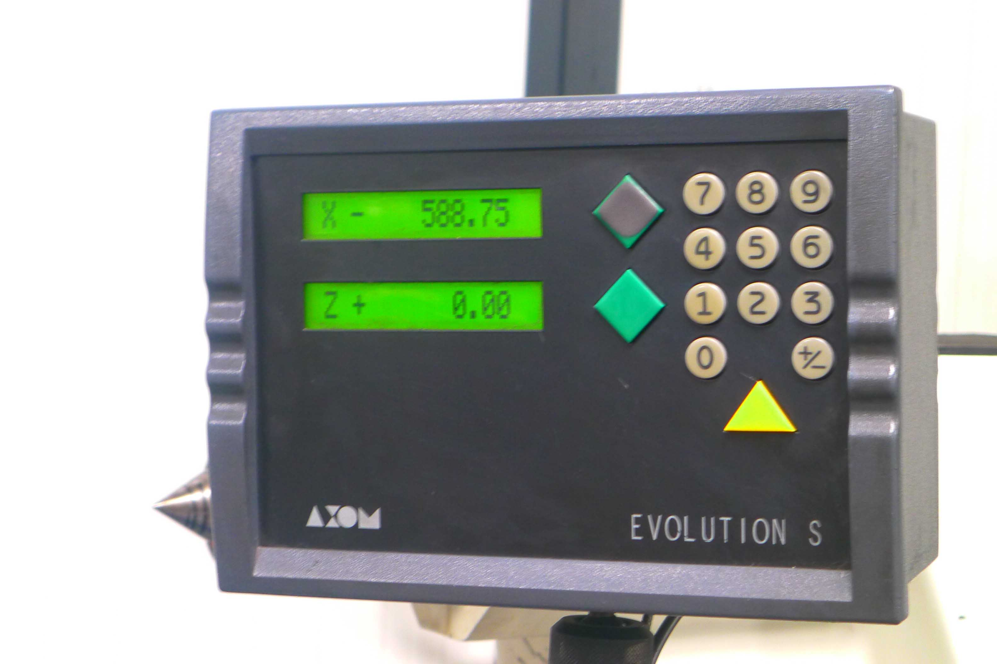
- Centre distance : 1.500
- Spindle bore : 155

- Speeds 22 steps : 8 – 1.000 Rpm
- Feeds in all directions

- Travel Manuel quill : 280
- Morse taper : Mk-6

- Work piece weight : 3.000
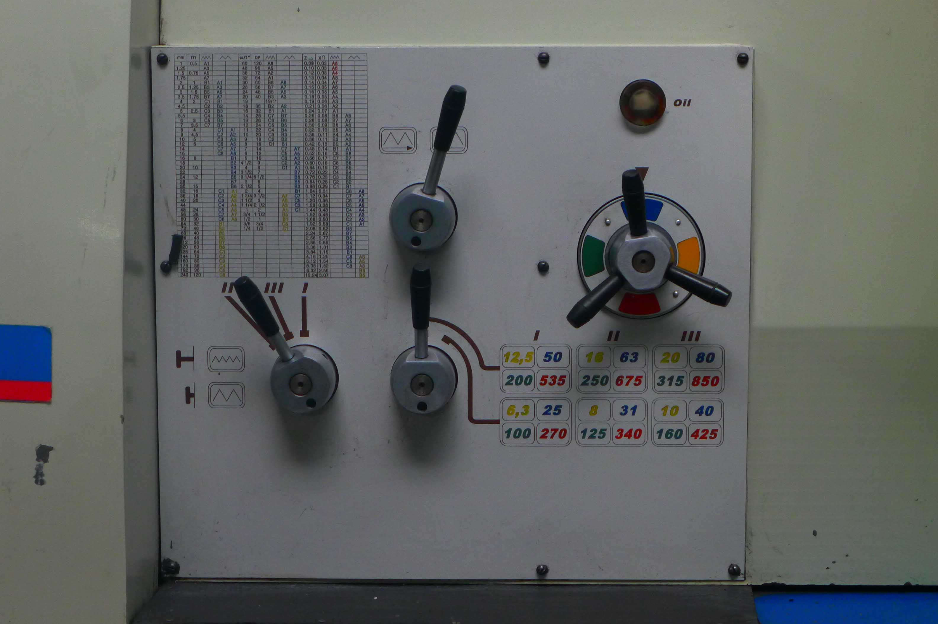
- Flying in the chuck : 1.250

- Dimensions
- Length : 3.530
- Width : 1.400
- Height : 1.660
- Weight : 5.400

- Incl. 4 chuck Ø 1.000
- Incl. 2 axis digital readout
- Incl. steady rest
- Incl. tool holder system

Please Note: The above information has been obtained to the best of our ability and belief from, and from the manufacturers where possible. It is given in good faith, but its accuracy can not be guaranteed. Accordingly, it will not form a representation or constitute contractual terms. We advise you to check any vital details!

